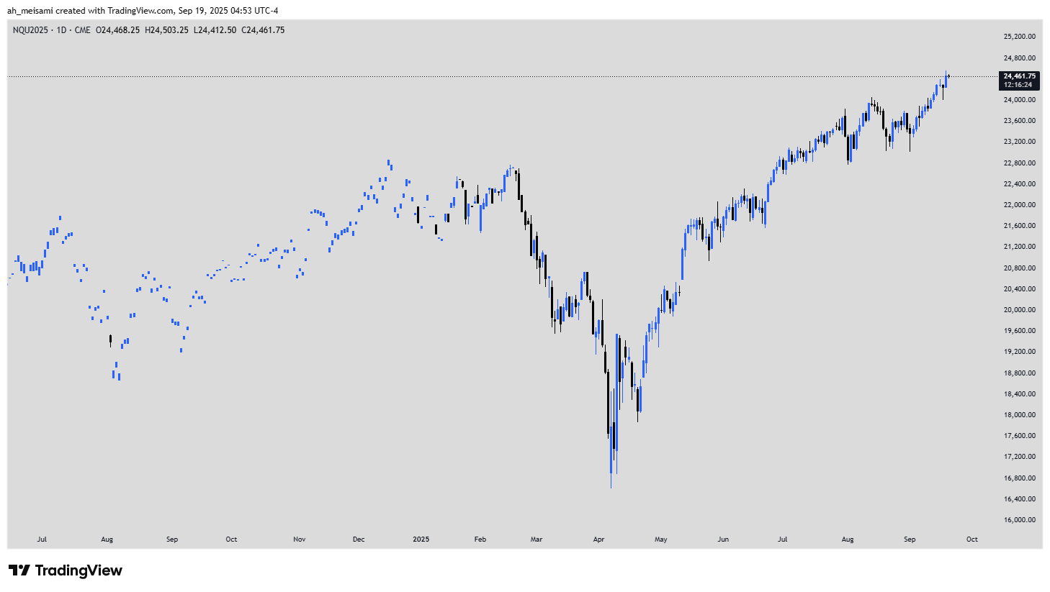

<https://www.tradingview.com/x/QgbAgizf/>

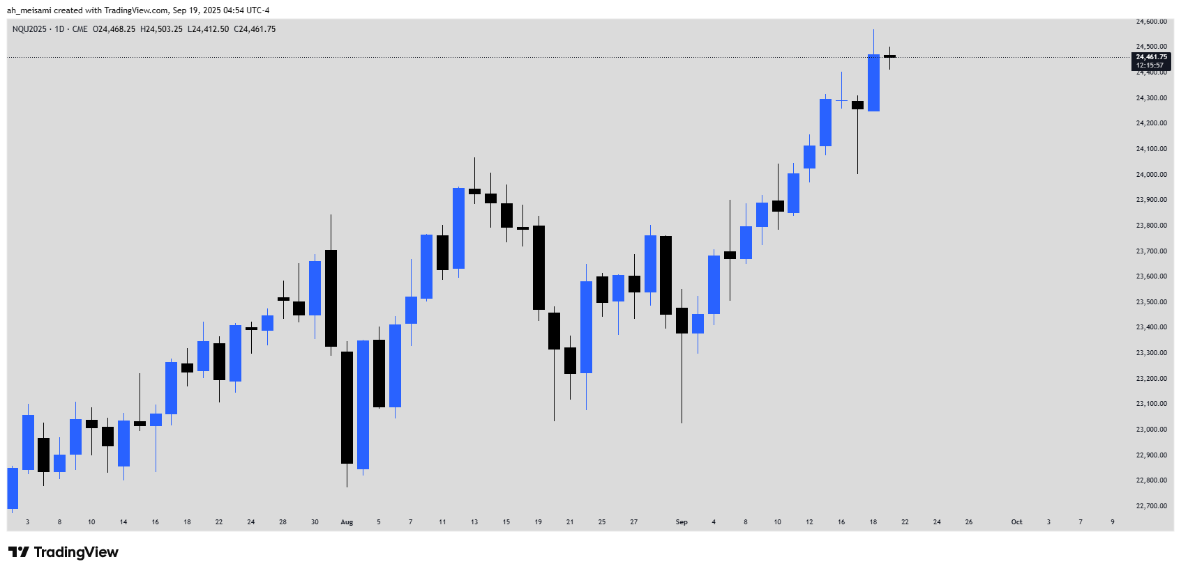

<https://www.tradingview.com/x/2nzfuWHp/>

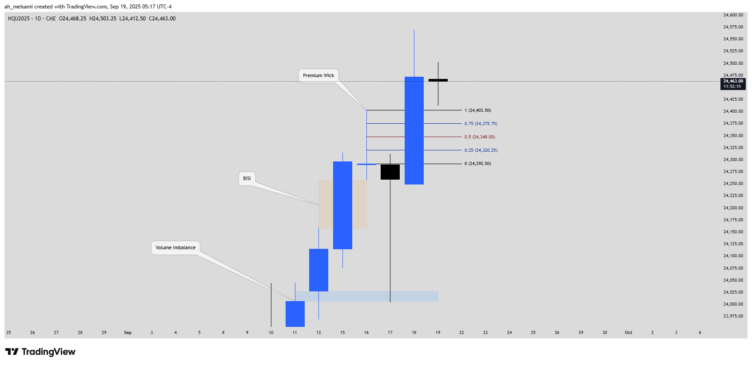

<https://www.tradingview.com/x/2uCK3HSq/>

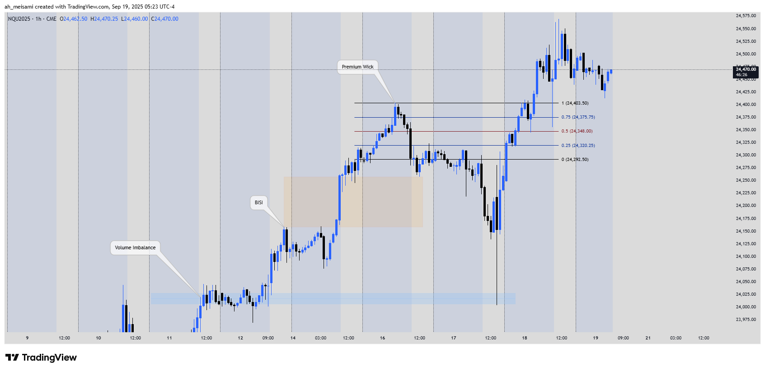

<https://www.tradingview.com/x/q4TLQ98r/>

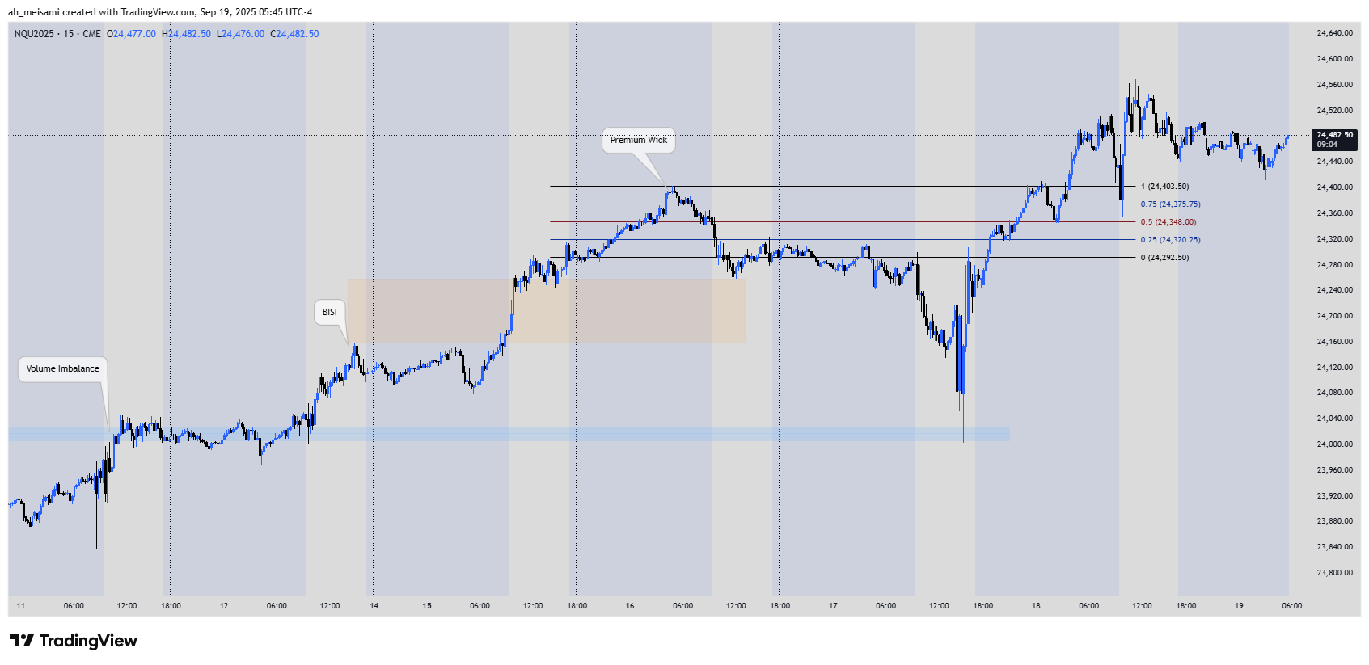

<https://www.tradingview.com/x/ylqD31AF/>

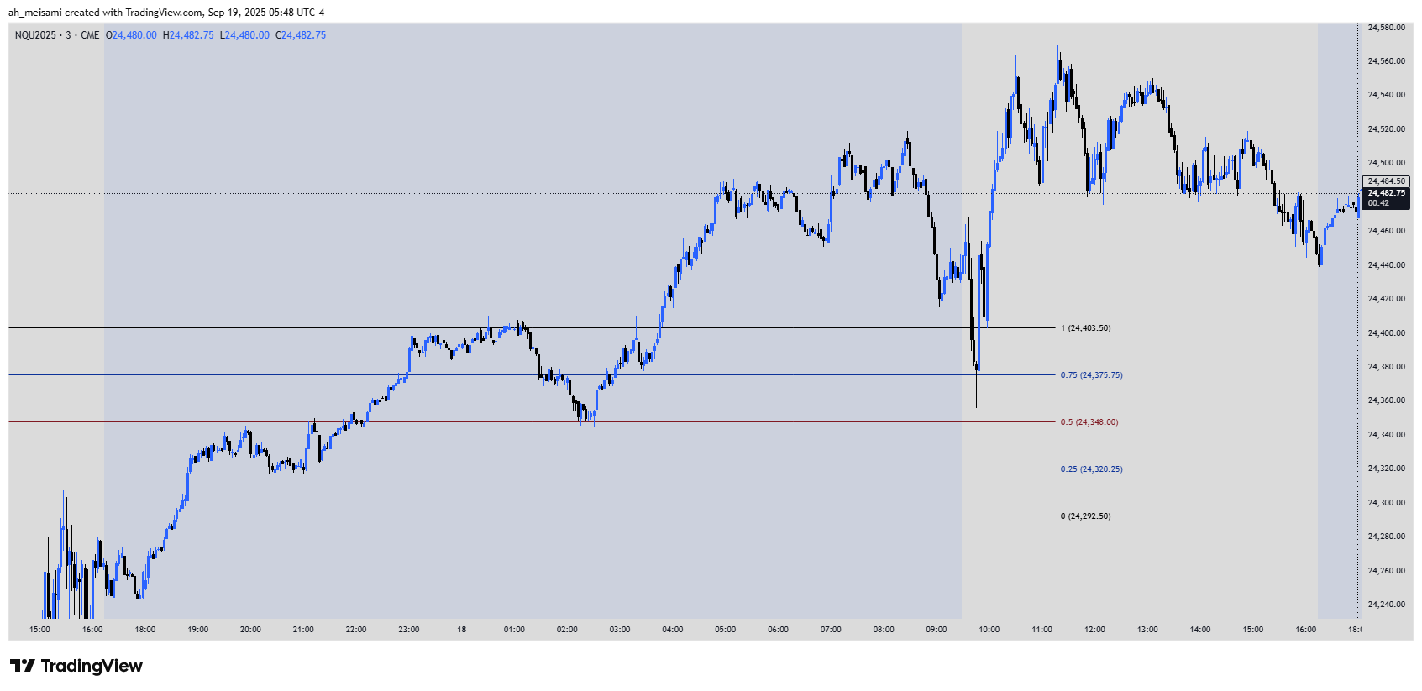<https://www.tradingview.com/x/XJW5VoWp/>

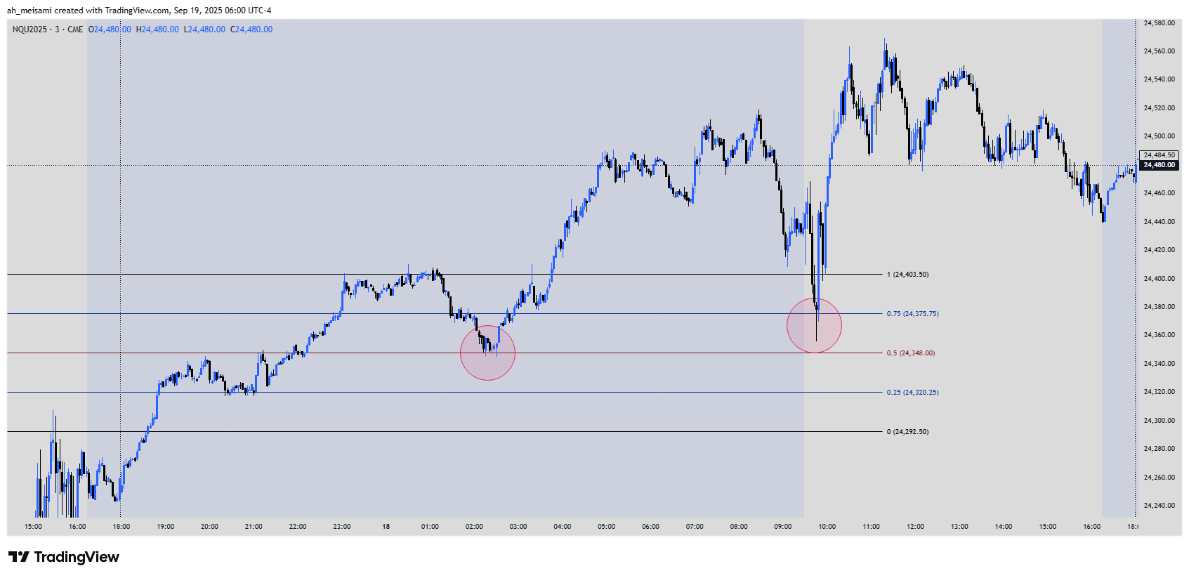<https://www.tradingview.com/x/F7NDeSDv/>

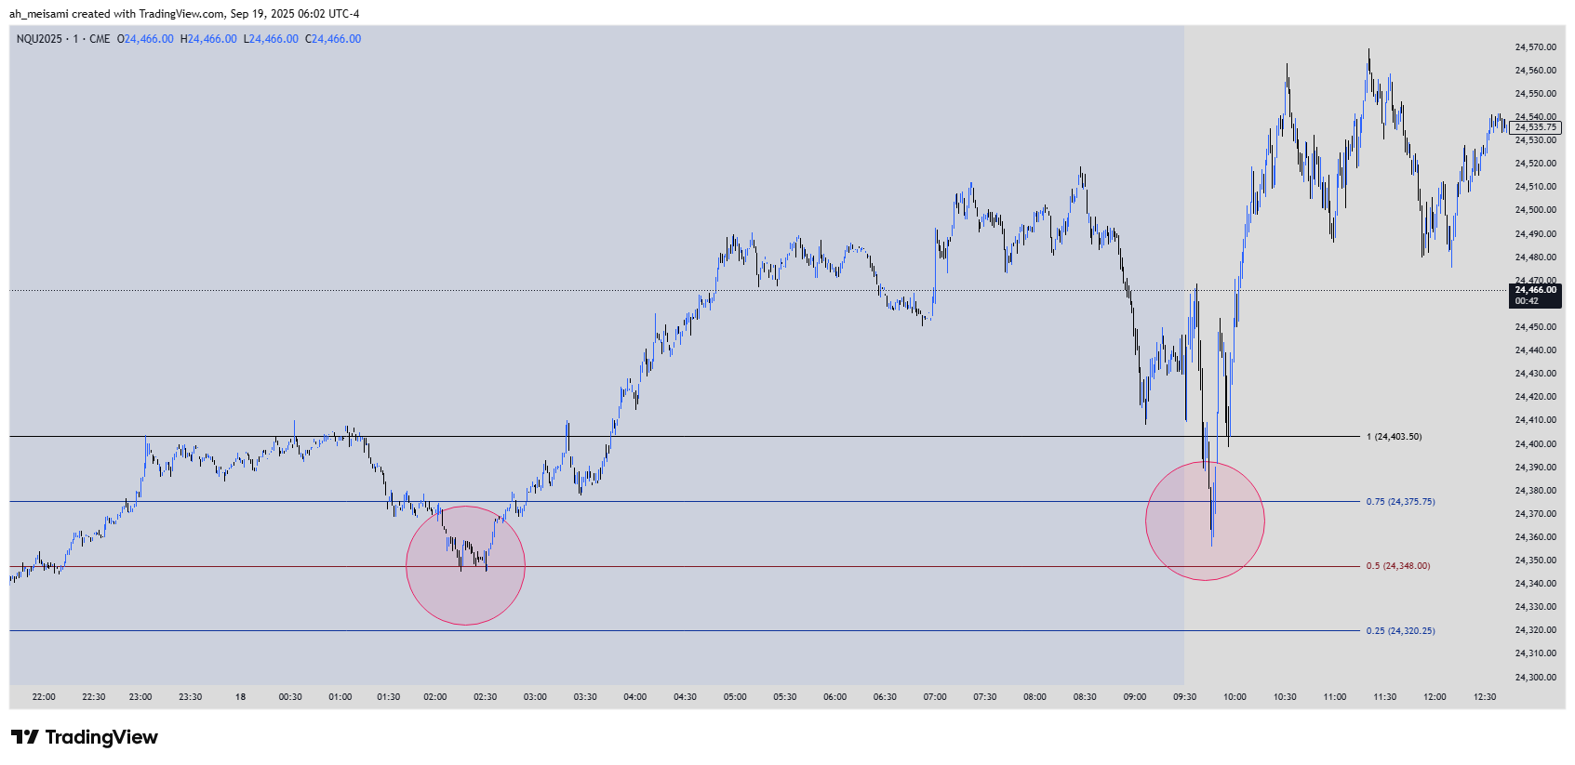<https://www.tradingview.com/x/zY3BVQoJ/>

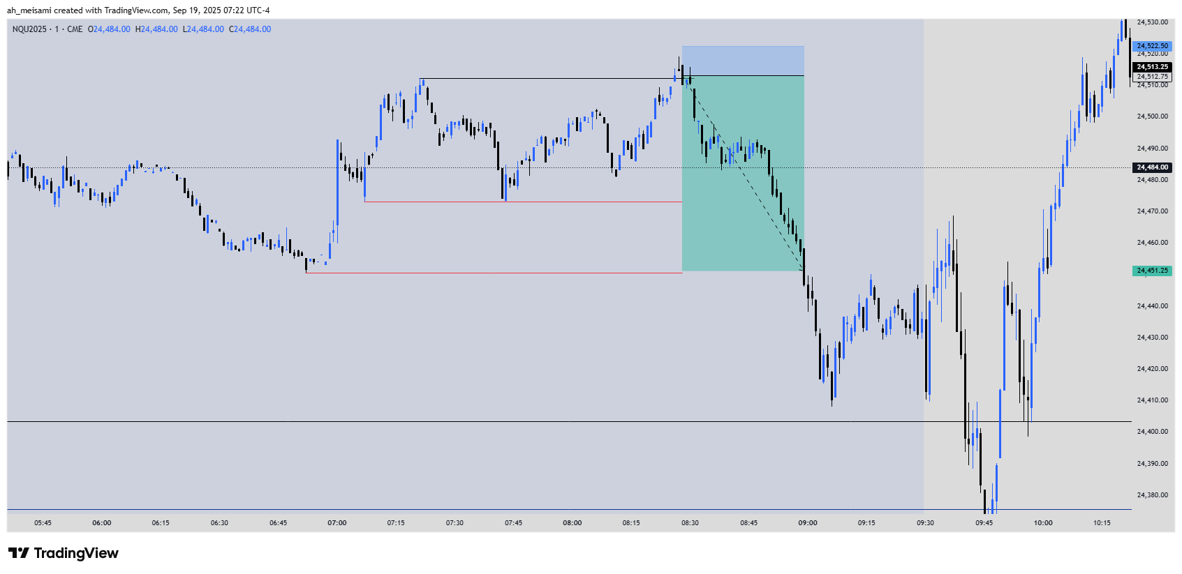

<https://www.tradingview.com/x/LPSbEyf5/>

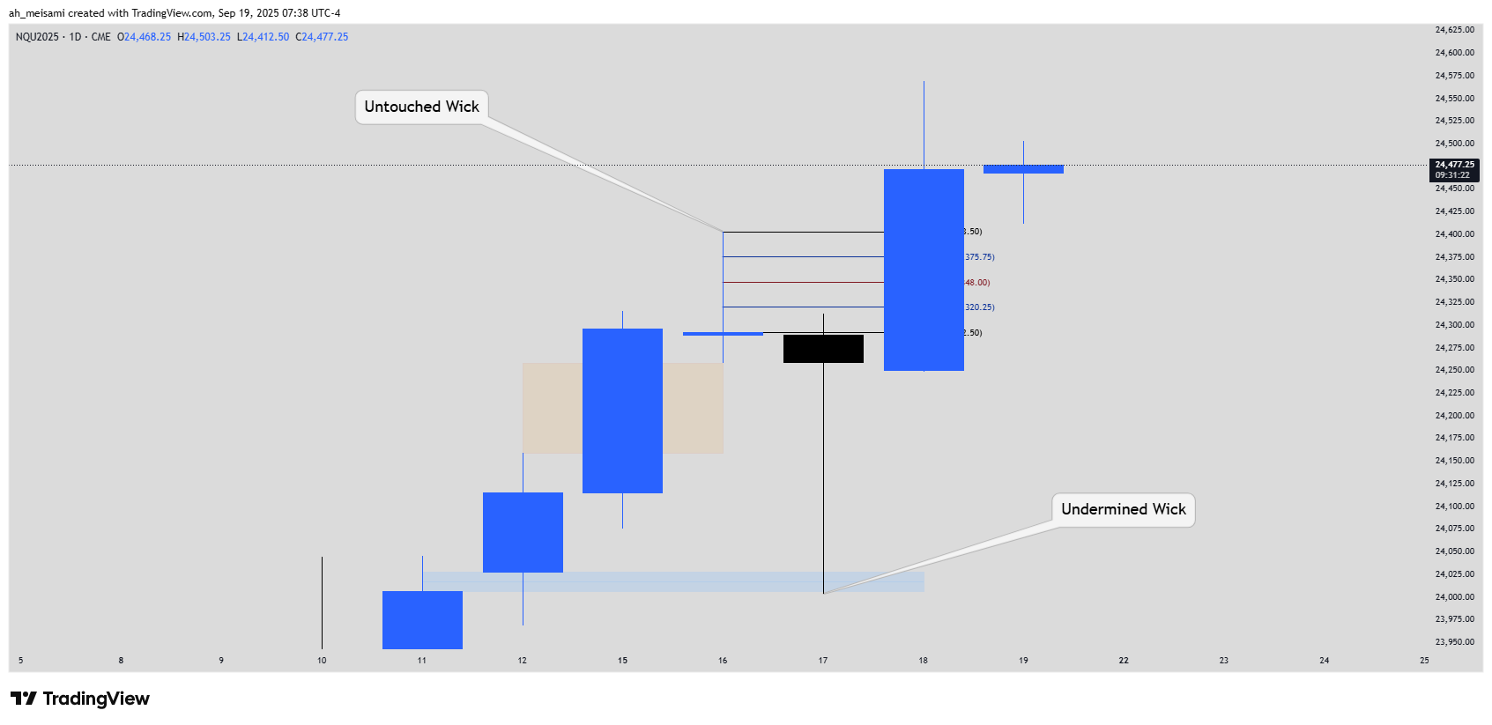 <https://www.tradingview.com/x/OISg3Iv7/>

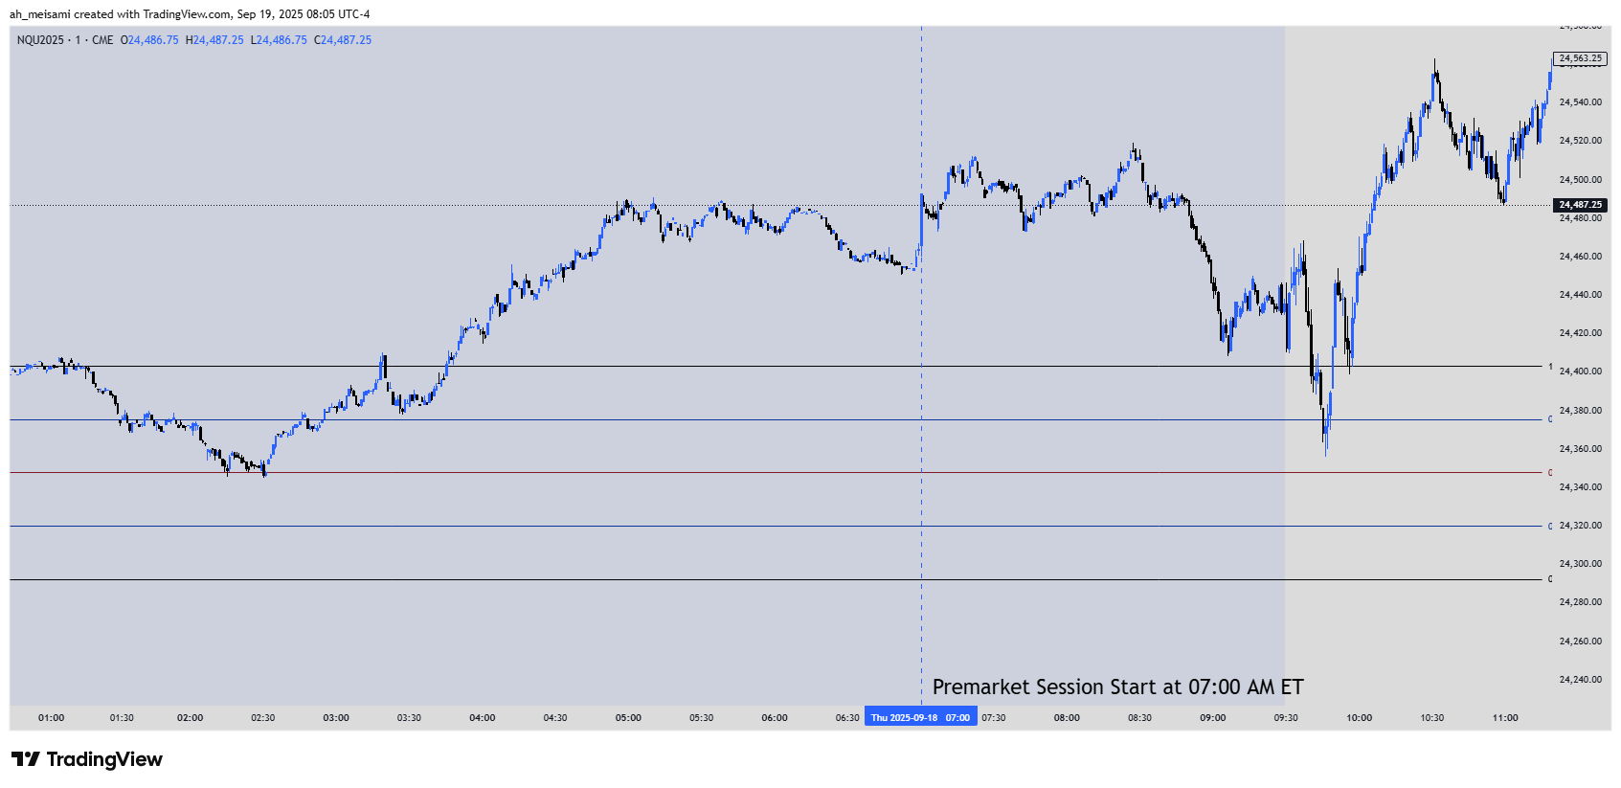

<https://www.tradingview.com/x/A0CMzam3/>

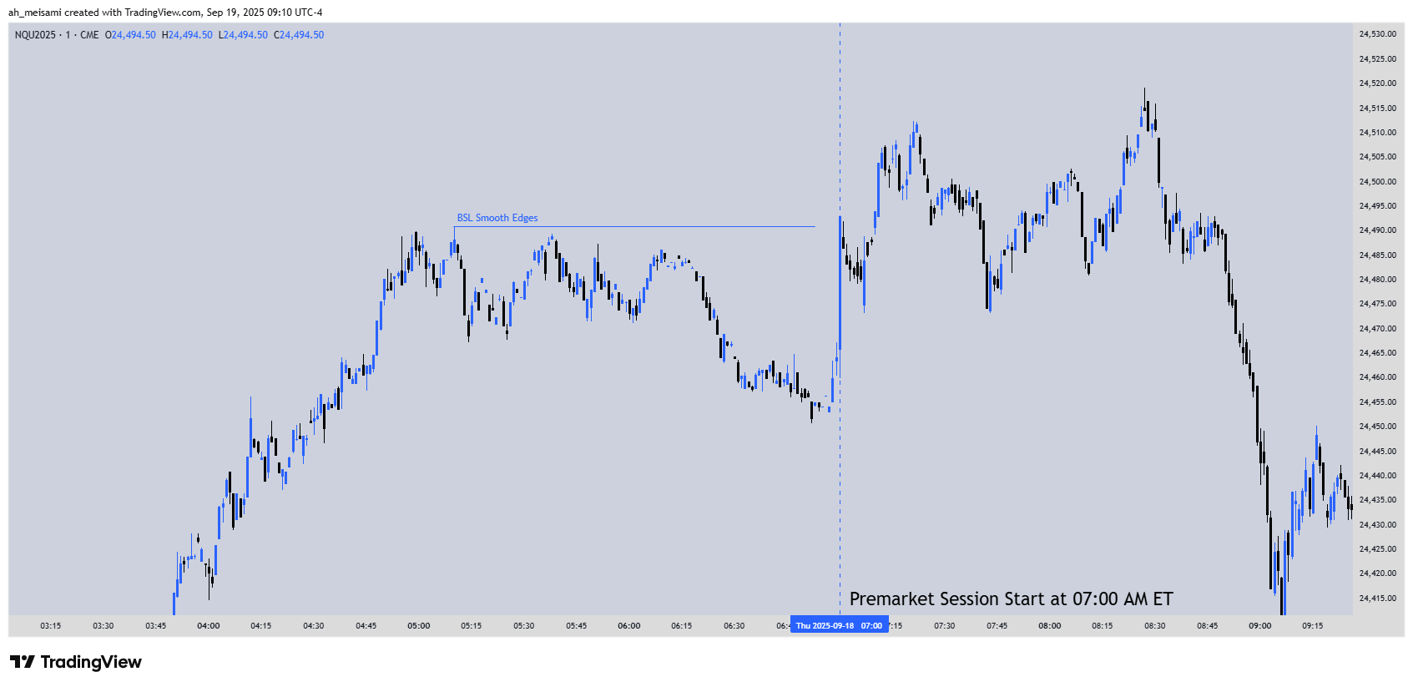 <https://www.tradingview.com/x/q2Zz9M9G/>

The market is the easiest thing to participate in.

It can be traded with simple decision making processes, many of which have no real correlation to why any market will rise or fall.

Or one can exercise diligence and statistical probabilities with historical evidence that there is nothing random in the delivery of price.

Sure, any country bumpkin can buy a lottery ticket and hit a windfall jackpot, but those odds are so low and I don't subscribe to the poor man's 401k of lottery mindset. This is what 'tik tok' Traders expect.

Those who want to unlock the mysteries of the market, won't expect simple or infantile perspectives of trading.

I abhor the likes of those who sheepishly state that my work is complicating trading. When there is nothing as precise or consistent and you can place whomever or whatever you like against it... it will pale in comparison.

When I read or hear people say things like that... I know beyond a shadow of a doubt that they are lazy, undisciplined, entitled and frankly unworthy of it.

In an age where 30 second tik tok clips cause brain rot and stoke the embers of impatience... many assume precision in the hands of those who forged their craft, over time and patience, can be acquired in tik tok level learning.

No... it will require you to defer your wants and desires of being a Market Wizard overnight to impress people you don't know... and those facts divide the can't do from those who can do.

Choose this day which you are.

<https://x.com/I_Am_The_ICT/status/1969013431610065116>